Luz Deloria

Lab 6

10/29/18

Instructions: •

Clear your browser history, and visit:

http://gaia.cs.umass.edu/wireshark-labs/HTTPethereal-lab-file3.html

(your browser should display the US Bill of Rights)

• Using Wireshark, capture the packets. Remember to start, then visit webpage, and then stop.

• We are going to analyze Ethernet frames.

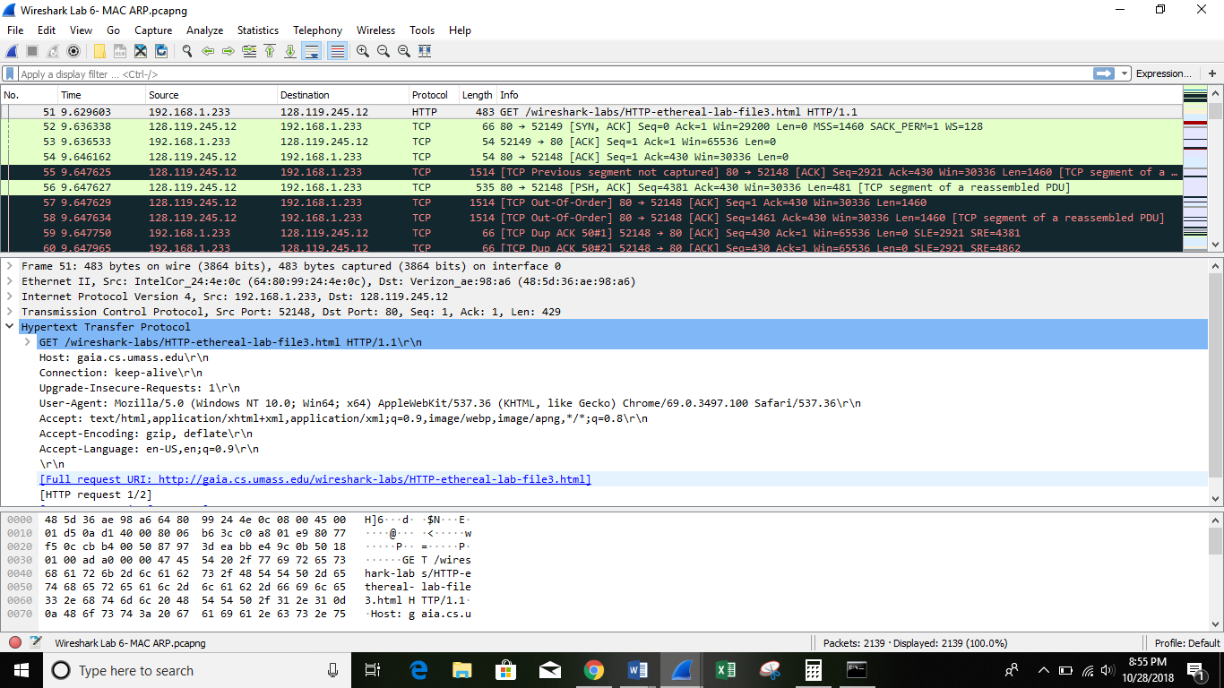

• Take a screenshot of your IP address (this is not part of your grade)

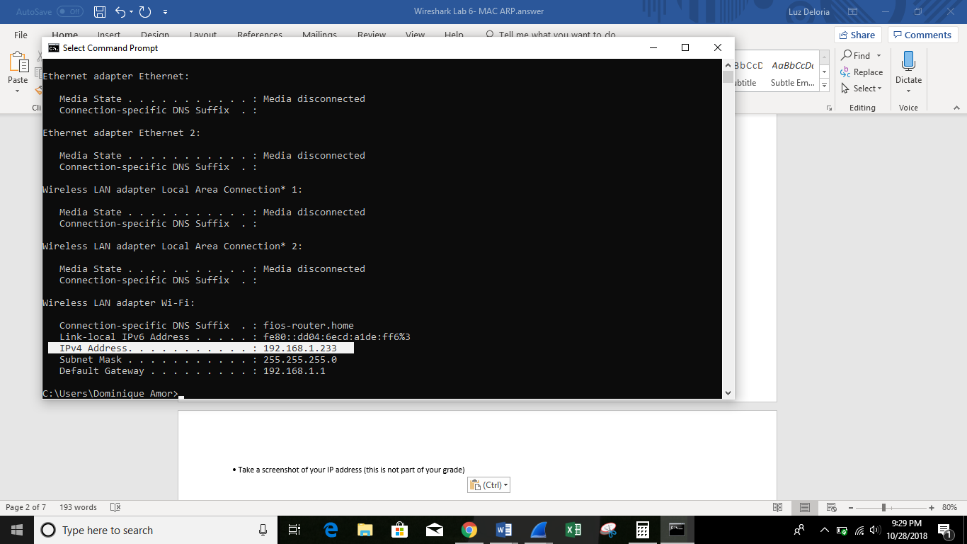

Questions:

1. What is the MAC address from your computer?

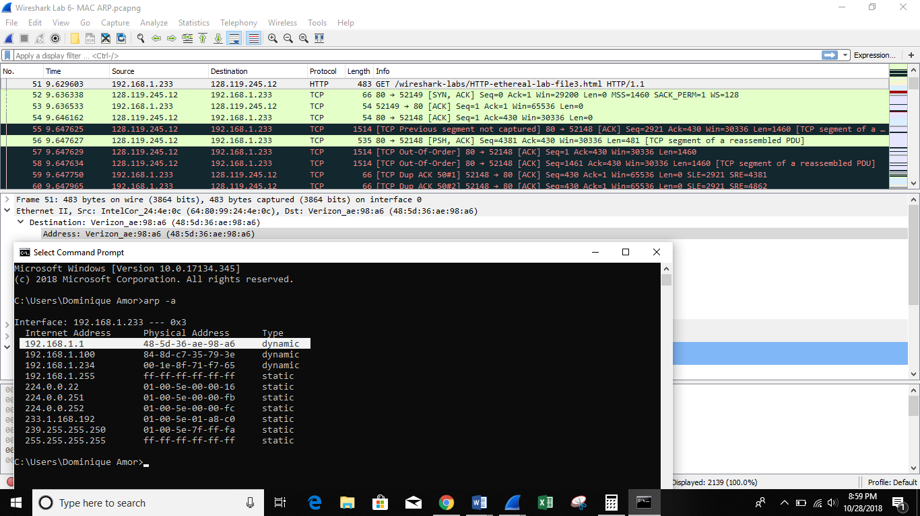

2. What is the destination MAC address?

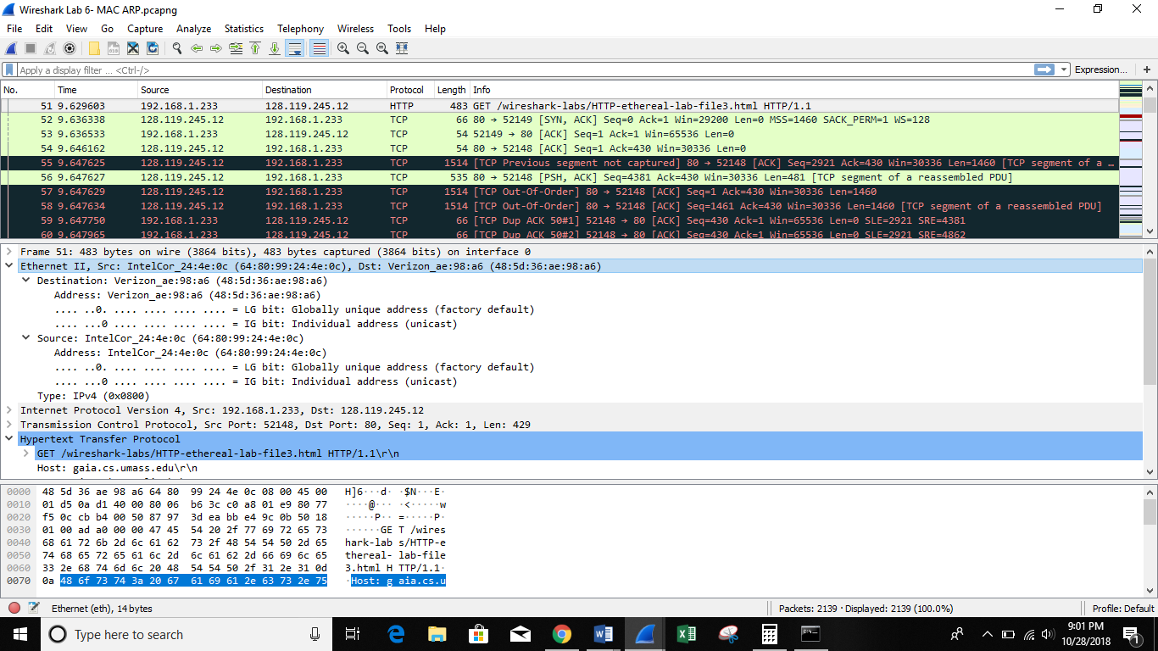

3. What device has the MAC address shown in the destination?

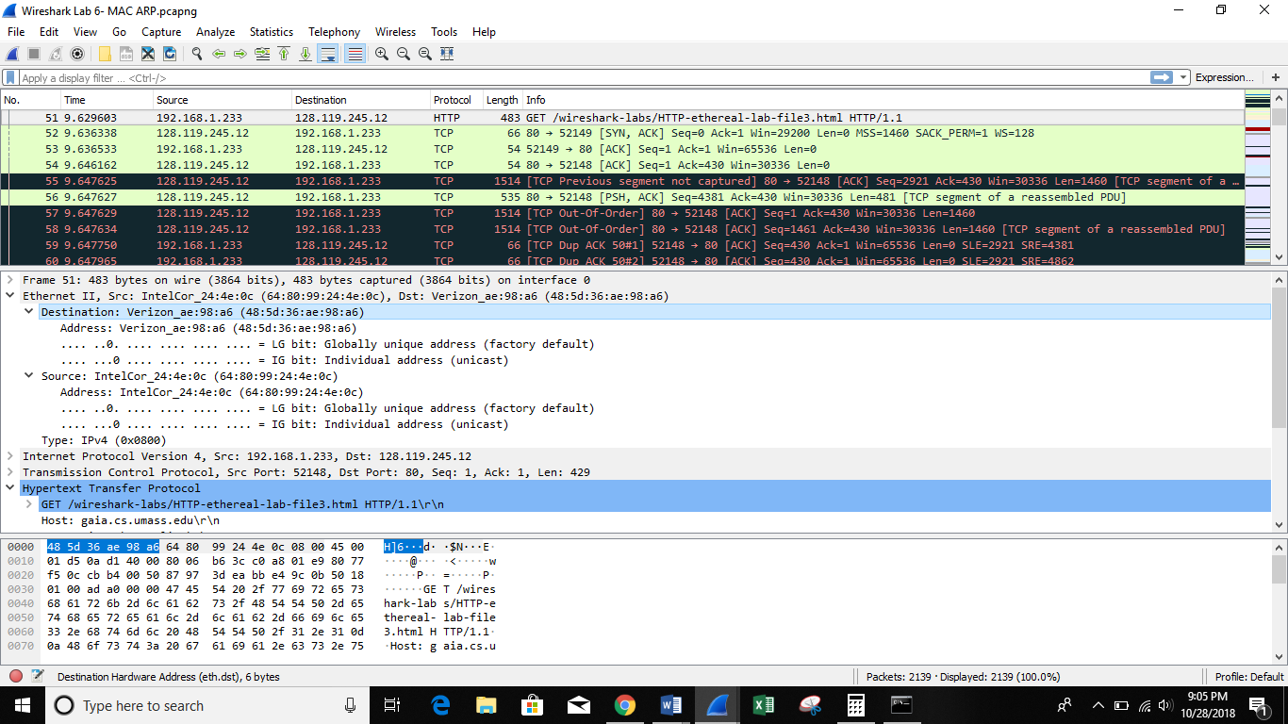

4. Explain the relationship between the destination MAC address and the destination IP address.

🡪MAC address is a UNIQUE address given to a machine while an IP address is used to identify a machine over the internet (public & private). The ARP (Address Resolution Protocol) cache is the link between them. ARP’s job is to map IP address to MAC address.

5. Using the terminal (cmd in Windows, Terminal in mac), run a command to display your full ARP list table. (Find out what the command is, and print a full screen shot of your result.)

🡪**ipconfig /all** is a command to display your full ARP list table.

